**BTW ML/DL Assignment 2**

**Question 1:**

In this question I have initialized an empty dictionary and then and then enter user input values in it, for email checking I’ve used regex to compare user input email with the email pattern and used while loop so that when user enters wrong email address or not according to the given pattern, he should enter again.

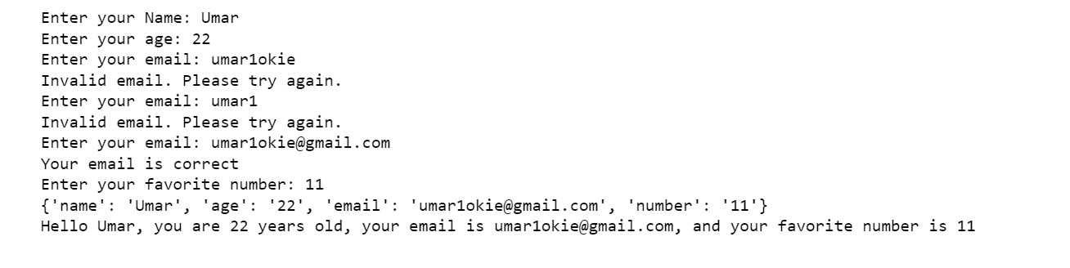

**Question 2:**

In this question I have use only one condition that if number is not divisible by 2 then that number is odd.

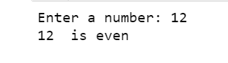

**Question 3:**

Parameter in this question were used to identify the formula for converting Fahrenheit scale to Celsius and vice versa scale parameter was assigned with Fahrenheit and Celsius if temperature is entered it would convert fahrenheit to Celsius aand vice versa.



**Question 4:**

2 variable were created and were assigned with empty list one is going to hold max value and the other minimum value random value is going to iterate through list and assign max value to max variable and minimum value min variable, list was created by user value were put in.

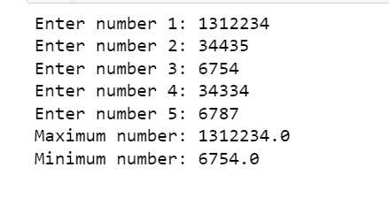

**Question 5:**

**Initialize an empty list that** will hold tuples containing details for each student. Using a loop to iterate 3 times (for 3 students) and prompt the user to enter details. For each iteration collect the details and pack them into a tuple. Then used dictionary comprehension that converts the list of tuples into a dictionary with student names as keys and their details as values.

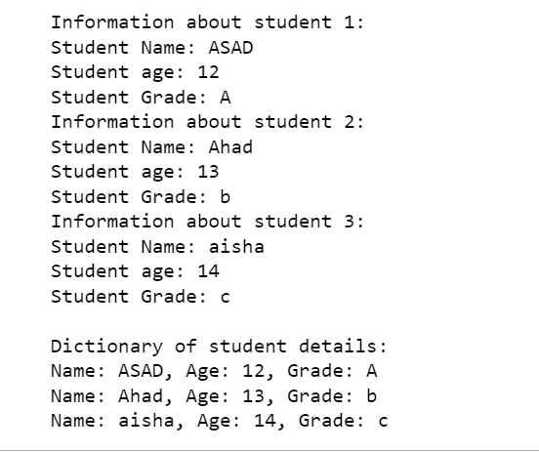

**Question 6:**

The code initializes an inventory with predefined items and quantities. It then allows the user to update the inventory by specifying whether to add or remove quantities for three different items. During this process, the code ensures that item quantities do not fall below zero. After the updates, it prints both the initial and updated inventories to the console.

